How Our Solar System Formed
Google ClassroomFacebookTwitter
Email
A close look at the planets orbiting our Sun. Planets are born from the clouds of gas and dust that orbit new stars. Billions of years ago, circumstances were just right for Earth and the other planets in our Solar System to form.
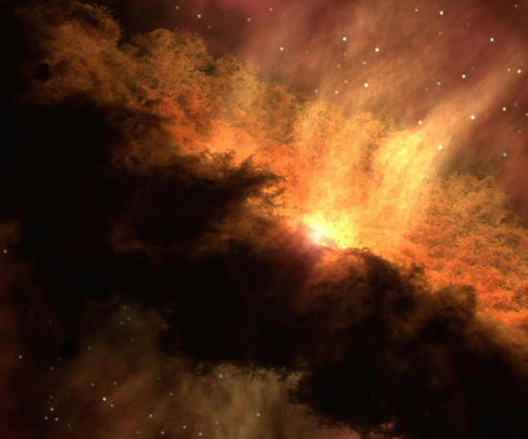
Illustration of a fledgling solar system. Source: NASA/JPL-Caltech
The Solar System that we live in consists of a medium-size star (the Sun) with eight planets orbiting it. The planets are of two different types. The four inner planets, those closest to the Sun, are Mercury, Venus, Earth, and Mars. They are smaller and composed mainly of metals and rocks. The four outer planets — Jupiter, Saturn, Uranus, and Neptune — are larger and composed mostly of gases.
What are planets? Where did they come from? Why would some be rocky and some gaseous? What is our planet like? This essay will try to answer these questions.
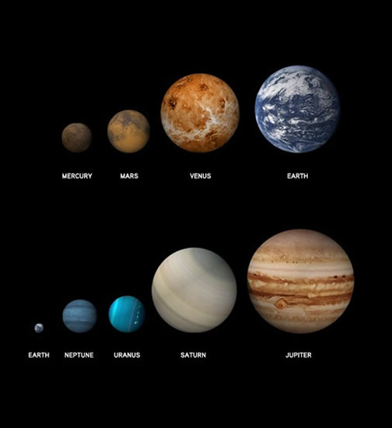
Each of the planets in our Solar System is unique. They vary in size and composition. Source: NASA and the Big History Project

The Birth of the Sun
Let’s quickly review how our star came into being. Five billion years ago, a giant cloud floated in one of the spiral arms of the Milky Way galaxy. This cloud, called a nebula by astronomers, was made up of dust and gas, mostly hydrogen and helium, with a small percentage of heavier atoms. These heavier atoms had been formed earlier in the history of the Universe when other stars aged and died.
This cloud/nebula began to contract, collapsing in on itself. The atoms, once separated, began to jostle each other, generating heat. In the rising heat, the atoms collided more frequently and more violently. Eventually, they reached a temperature at which the protons at the centers of the atoms began to fuse, in a process called nuclear fusion. As they did, a tiny bit of matter transformed into a whole lot of energy, and a star was born. In this way, our Sun came into being.

The Birth of the Planets
The material in the nebula not absorbed into the Sun swirled around it into a flat disk of dust and gas, held in orbit by the Sun’s gravity. This disk is called an accretion disk. Material in the disk accumulated by further accretion — from sticking together.
Each planet began as microscopic grains of dust in the accretion disk. The atoms and molecules began to stick together, or accrete, into larger particles. By gentle collisions, some grains built up into balls and then into objects a mile in diameter, called planetesimals. These objects were big enough to attract others by gravity rather than by chance.
If the collisions of planetesimals occurred at high speeds, they could shatter the objects. But when impacts were gentle enough, the objects combined and grew. For some 10 to 100 million years these protoplanets orbited the Sun, some in egg-shaped circuits that resulted in more frequent collisions.
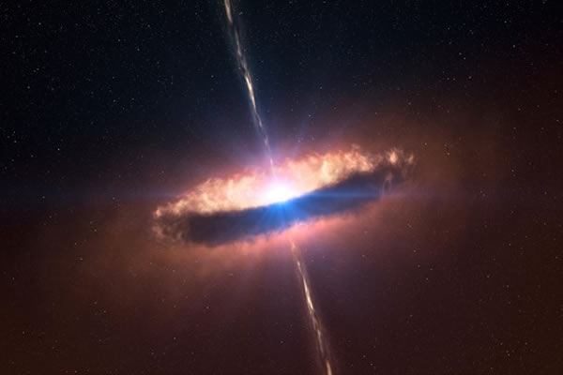
This illustration shows the accretion disk of a star that, like our Sun, could go on to form planets from the dust and gas around it. Source: ESO/L. Calçada
Worlds collided, combined, and evolved for a dramatic period of time. When it was over, there remained eight stable planets that had swept their orbits clean. A planet is defined as a body that orbits the Sun, is massive enough for its own gravity to make it spherical, and has cleaned its neighborhood of smaller objects.
In 2007, researchers at the University of California–Davis determined that our Solar System was fully formed at 4.568 billion years ago. They did this by determining the age of stony materials from the asteroid belt.
The Sun sent out energy and particles in a steady stream, called stellar winds. These winds proved so strong that they blew off mostthe gases of the four planets closest to the Sun, leaving them smaller, with only their rocks and metals intact. That’s why they are called rocky, or terrestrial, planets. The four outer planets were so far from the Sun that its winds could not blow away their ice and gases. They remained gaseous, with only a small rocky core.
They were made of more gas (namely hydrogen and helium) than the others to begin with, the Sun’s gravity having pulled closer the heavier materials in the original solar disk.
Between the inner and outer planets lies an area filled with millions of asteroids — small rocky, icy, and metallic bodies left over from the formation of the Solar System. No planet formed in this area. Astronomers theorize that Jupiter’s gravity influenced this region so much that no large planet could take shape. Jupiter is 11 times the size (in diameter) of Earth and more than twice as big as all the other planets combined. It is almost large enough to have become a star.
Of the four rocky planets, Mercury is the smallest, about two-fifths the size of Earth. Earth and Venus are almost the same size, while Mars is about half their size. Astronomers speculate that a smaller object must have hit Mercury, vaporizing its crust and leaving only the larger-than-usual iron core.

Conditions on Earth
When the rocky planets first formed, they were largely melted (molten) rock. Over hundreds of millions of years, they slowly cooled. Eventually Mercury and Mars, because they are small, solidified and became rigid all the way to their centers.
Only on Earth, and possibly on Venus, have conditions remained in an in- between state. Earth has stayed partially molten. Its crust is solid rock, and its mantle is rigid in short-term time. But over geologic time the mantle flows slowly. And the center of Earth consists of a solid iron core rotating in hot liquid called magma.
Some scientists and Big Historians use the term “Goldilocks Conditions” to describe conditions on Earth. This comes from an Anglo-Saxon children’s story, “Goldilocks and the Three Bears.” In the story, a young girl named Goldilocks wanders into the home of three bears, who are away. She tries out their porridge, their chairs, and their beds, finding some too hot or too cold, too hard or too soft, too large or too small, but one of each just right. Likewise, Earth is not too hot or too cold, not too big or too little, not too near the Sun or too far away, but just right for life to flourish.

Earth’s Moon
The rocky object nearest to us is the Moon. Where did it come from? Good question. The Moon orbits Earth, not the Sun, so it is not a planet. The Moon is about one-fourth the size of Earth. The origin of the Moon remains mysterious, but since astronauts walked on the Moon in 1969 and brought back rock and soil samples, we know more about it now than before.
The standard argument today holds that a small contending planet, about one-tenth the size of Earth, must have collided with Earth about 4.45 billion years ago. Earth was still red-hot beneath a possible thin new crust. Some of the material from the impact was absorbed into the liquefied Earth but some material ricocheted into space, where it settled into orbit and condensed as the Moon. At first the Moon orbited much closer to Earth. It is still moving away at a rate of almost two inches (four centimeters) per year.
The Moon significantly affects conditions on Earth. The impact that produced the Moon tilted Earth on its axis. This causes Earth’s seasonal variations in temperature, since the side tilted toward the Sun for one-half the year’s journey around the Sun receives more direct sunlight. Also, the Moon’s gravity causes the oceans’ tides, reduces the Earth’s wobble (which helps stabilize climate), and slows the spin of the Earth. The Earth used to complete a rotation on its axis in 12 hours, but now it takes 24.

Pluto and Beyond
Before 2006, students learned that our Solar System had nine planets, not eight. The one counted as the ninth, Pluto, orbits furthest from our Sun.
However, in 2006, the International Astronomical Union declared that Pluto does not count as a planet. It is smaller than Earth’s Moon. It orbits way out in a belt of asteroids beyond Neptune (though Pluto periodically comes closer to the Sun than Neptune), and does not have enough gravity to clear the neighborhood around its path. Therefore, it was downgraded to a “dwarf planet,” or a planetesimal.
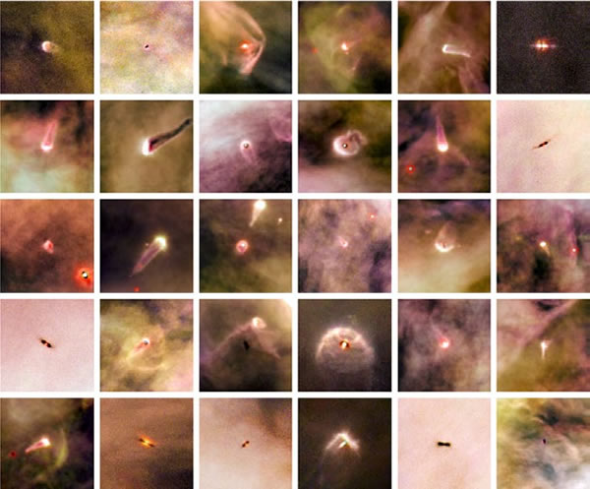
Dust-and-gas clouds surround nascent stars in the Orion Nebula. Proplyds in the Orion Nebula. Source: NASA/ESA and L. Ricci (ESO)
Astronomers feel confident that our Solar System formed by accretion because now they are able to glimpse a similar process occurring in part of the Orion Nebula. This planet-forming area is on the near side of a giant cloud complex that embraces much of the constellation Orion, 1,500 light- years from Earth. Since 1993, astronomers have discovered several hundred stars there in the process of formation, most of them surrounded by rings of dust in accretion disks, just like the one they believe produced the solar planets. These clouds of dust and gas around new stars in the Orion Nebula may develop into planetary systems similar to our own.
In 1995, astronomers in Switzerland found, for the first time, a planet beyond our Solar System orbiting an ordinary star. Such a planet is called an extrasolar planet, or an exoplanet. As of June 2012, more than 700 exoplanets had been discovered and confirmed. Most of them are giants, closer in size to Jupiter, as larger planets have proved easier to detect hundreds of light-years away. Most are detected not by direct imaging, but indirectly by measuring the effect of their gravity on their parent star or by observing how the light of the parent star dims as the planet passes in front of it.
In 2009, the National Aeronautics and Space Administration (NASA) sent a telescope into orbit around the Sun to hunt for habitable exoplanets in the region near the constellations Cygnus and Lyra. This telescope (actually a photometer), the centerpiece of what’s known as the Kepler mission, will monitor 100,000 stars a few hundred to a few thousand light-years away. (One light-year equals 6 trillion miles.) The mission will last three and a half to six years; in the first two years, it has found 17 planets with conditions thought to allow for the development of life.
In summary, planets are bodies orbiting a star. Planets form from particles in a disk of gas and dust, colliding and sticking together as they orbit the star. The planets nearest to the star tend to be rockier because the star’s wind blows away their gases and because they are made of heavier materials attracted by the star’s gravity. In the Sun’s system, Earth is one of four rocky planets, but a unique one, with rigid and molten layers.
By Cynthia Stokes Brown

